COMP214

Advanced Database Concepts

Sec -005

ONLINE BOOKSTORE DATABASE MANAGEMENT SYSTEM

Centennial college

|  |  |
| --- | --- |
| Group Members | ID |
| Prachi Patel | **301272750** |
| Sakshi Shingala | **301286045** |
| Keta Patel | **301283759** |
| Aishwarya Pawar | **301299470** |
| Manav Patel | **301297156** |
| Shaima Rahman | **301269459** |

**Professor:** Farhan Mazar

TABLE OF CONTENTS

|  |  |
| --- | --- |
| 1.INTRODUCTION……………………………………………………………………………3 |  |
| 2.DATA REQUIREMENT PHASE………………………………………………………4 |  |
| 3.CONCEPTUAL DATA MODELING PHASE…..…………………………………..9  **3.1 ERD DIAGRAM……………………………………………………………….15**  **3.2 RELATIONSHIP BETWEEN TABLES……………………………………16**  **3.3 ACCESS AND CONTENT CONTROLS…………………………………18** |  |
| 4.LOGICAL DATABASE DESIGN PHASE ……………………………………………21  **4.1 OBJECTIVE ……………………………………………………………………..21**  **4.2 DESIGN GOALS………………………………………………………………..21**  **4.3 FUNCTIONALITIES …………………………………………………………….21**  **4.4 BUSINESS RULES ……………………………………………………………..22**  **4.5 DDL FOR ONLINE BOOKSTORE MANAGEMENT…………………24**  **4.6 DML FOR ONLINE BOOKSTORE MANAGEMENT …………….. 32**  **5 PHYSICAL DATABASE DESIGN PHASE ………………………………….37**  **5.1 SEQUENCE …………………………………………………………………..37**  **5.2 VIEWS…………………………………………………………………………..37**  **5.3 CURSOR ..……………………………………………………………………38**  **5.4 FUNCTION …………………………………………………………………..40**  **5.5 PROCEDURE ………………………………………………………………….42**  **5.6 TRIGGERS……………………………………………………………………43**  **5.7 PACKAGES …………………………………………………………………..45** |  |
|  |  |

# **INTRODUCTION**

**Online Bookstore database management System**

An Online Bookstore DBMS is the digital curator that brings the magic of bookstores to the fingertips of readers worldwide. By structuring and managing data efficiently, it transforms a traditional bookstore into a dynamic online platform, where book lovers can explore an extensive catalog, obtain recommendations, and embark on literary journeys tailored to their preferences—all with the click of a button.

Online Bookstore DBMS, from managing vast inventories to tracking user preferences. This unseen architect ensures that every visit to the virtual bookstore is a personalized journey, with recommendation engines offering tailored suggestions based on individual reading habits. The real-time updates and secure transaction processing integrated into the DBMS not only enhance the functionality of the online bookstore but also contribute to a secure and enjoyable environment for literary exploration.

The objective of this project is to develop an extensive backend database system for an online bookstore, streamlining operational processes. This system aims to provide users with the capability to effortlessly search for books, make purchases, and handle returns, thereby elevating their overall interaction with the platform. Furthermore, the system will empower bookstore personnel by facilitating tasks such as adding new books, adjusting prices, and generating crucial reports on a weekly and monthly basis.

## **DATA REQUIREMENT PHASE**

This database has been created to facilitate the functioning of an internet-based bookstore, encompassing the organization and administration of crucial information related to user engagements, book stock, order fulfillment, financial transactions, personnel oversight, inventory monitoring, analytical reporting, search capabilities, returns processing, as well as authentication and authorization procedures.

**1. Customer Information** :- Stores details about customers, including name, address, contact information, login credentials, and payment information.

* UserID
* CustomerName
* CustomerAddress
* CustomerEmail
* CustomerPhoneNumber
* CustomerUsername
* CustomerPassword
* PaymentInfo

1. **Book Information**:- Contains information about books, including title, author, publisher, genre, publication date, price, stock quantity, and category.

* BookID
* BookTitle
* BookAuthor
* BookPublisher
* BookGenre
* BookPublicationDate
* BookPrice
* StockQuantity
* BookCategory

**3. Order Information :-** Records details of orders, such as order ID, user ID, book ID, order date, delivery address, order status, and total cost.

* OrderID
* UserID
* BookID
* OrderDate
* DeliveryAddress
* OrderStatus
* Cost

**4.Transaction Information :-** Manages transaction details associated with orders, including transaction ID, order ID, payment status, payment method, and transaction date.

* TransactionID
* OrderID
* UserID
* BookID
* PaymentStatus
* PaymentMethod
* TransactionDate

**5. Employee Information : -** Stores employee details, including employee ID, name, position, username, and password.

* EmployeeID
* EmployeeName
* EmployeePosition
* EmployeeUsername
* EmployeePassword
* EmployeeEmail

**6. Stock Information : -** Tracks the quantity of each book in stock by associating it with the

Book id.

* BookID
* QuantityOfBook

**7. Publisher Information :** - Contains details about publishers, including publisher ID, associated book ID, name, address, email, and phone number

* PublisherID
* BookID
* PublisherName
* PublisherAddress
* PublisherEmail
* PublisherPhoneNumber

**8. Author Information : -** Manages information about authors, including author ID, associated book ID, name, address, email, and phone number.

* AuthorID
* BookID
* AuthorName
* AuthorAddress
* AuthorEmail
* AuthorPhoneNumber

**9.Discount Information : -** Stores details about discounts, including discount ID, associated book ID, discount code, percentage, and validity dates.

* DiscountID
* BookID
* DiscountCode
* DiscountPercentage
* ValidFrom
* ValidTo

**10.Promotion Information :-** Manages promotional offers, including promotion ID, name, description, promotion code, discount percentage, and validity dates.

* PromotionID
* BookID
* PromotionName
* PromotionDescription
* PromotionCode
* DiscountPercentage
* ValidFrom
* ValidTo

**11.Shipping Information : -** Records details about shipping, including shipping ID, associated order ID, shipping method, cost, and estimated delivery time.

* ShippingID
* OrderID
* ShippingMethod
* ShippingCost
* EstimatedDeliveryTime

**12.Category Information :** - Manages book categories, including category ID, associated book ID, category name, and category description.

* CategoryID
* BookID
* CategoryName
* CategoryDescription

**13. Review Information :** - Stores book reviews, including review ID, associated book ID, user ID, review text, rating, and review date.

* ReviewID
* BookID
* UserID
* ReviewText
* Rating
* ReviewDate

**14.Return Information : -** Tracks details related to product returns, including return ID, associated order ID, user ID, book ID, return date, reason, status, and refund amount.

* ReturnID
* OrderID
* UserID
* BookID
* ReturnDate
* ReturnStatus
* RefundAmount

### 3.1 CONCEPTUAL DATA MODELING PHASE

Conceptual schema for the tables in our online bookstore management system :-

1. **Customer_Information**

|  |  |  |  |
| --- | --- | --- | --- |
| Field Name | Data Type | Size | Key |
| UserID | INT | 70 | Primary Key |
| CustomerName | VARCHAR | 70 |  |
| CustomerAddress | VARCHAR | 70 |  |
| CustomerEmail | VARCHAR | 70 |  |
| CustomerPhoneNumber | VARCHAR | 70 |  |
| CustomerUserName | VARCHAR | 70 |  |
| CustomerPassword | VARCHAR | 70 |  |
| PaymentInfo | VARCHAR | 70 |  |

1. **Book_Information**

|  |  |  |  |
| --- | --- | --- | --- |
| Field Name | Data Type | Size | Key |
| BookID | INT | 70 | Primary Key |
| BookTitle | VARCHAR | 70 |  |
| BookAuthor | VARCHAR | 70 |  |
| BookPublisher | VARCHAR | 70 |  |
| BookGenre | VARCHAR | 70 |  |
| BookPublicationDate | VARCHAR | 70 |  |
| BookPrice | DECIMAL | 70 |  |
| StockQuantity | VARCHAR | 70 |  |
| BookCategory | VARCHAR | 70 |  |

1. **Order_Information**

|  |  |  |  |
| --- | --- | --- | --- |
| Field Name | Data Type | Size | Key |
| OrderID | INT | 70 | Primary Key |
| UserID | INT | 70 | Foreign Key |
| BookID | INT | 70 | Foreign Key |
| OrderDate | TIMESTAMP | 70 |  |
| DeliverAddress | VARCHAR | 70 |  |
| OrderStatus | VARCHAR | 70 |  |
| Cost | DECIMAL | 70 |  |

1. **Transaction_Information**

|  |  |  |  |
| --- | --- | --- | --- |
| Field Name | Data Type | Size | Key |
| TransactionID | INT | 70 | Primary Key |
| OrderID | INT | 70 | Foreign Key |
| UserID | INT | 70 | Foreign Key |
| BookID | INT | 70 | Foreign Key |
| PaymentStatus | VARCHAR | 70 |  |
| PaymentMethod | VARCHAR | 70 |  |
| TransactionDate | TIMESTAMP | 70 |  |

1. **Employee_Information**

|  |  |  |  |
| --- | --- | --- | --- |
| Field Name | Data Type | Size | Key |
| EmployeeID | INT | 70 | Primary Key |
| EmployeeName | VARCHAR | 70 |  |
| EmployeePosition | VARCHAR | 70 |  |
| EmployeeEmail | VARCHAR | 70 |  |
| EmployeeUserName | VARCHAR | 70 |  |
| EmployeePassword | VARCHAR | 70 |  |

1. **Stock_Information**

|  |  |  |  |
| --- | --- | --- | --- |
| Field Name | Data Type | Size | Key |
| BookID | INT | 70 | Foreign Key |
| QuantityOfBook | INT | 70 |  |

1. **Publisher_Information**

|  |  |  |  |
| --- | --- | --- | --- |
| Field Name | Data Type | Size | Key |
| PublisherID | INT | 70 | Primary Key |
| BookID | INT | 70 | Foreign Key |
| PublisherName | VARCHAR | 70 |  |
| PublisherAddress | VARCHAR | 70 |  |
| PublisherEmail | VARCHAR | 70 |  |
| PublisherPhoneNumber | VARCHAR | 70 |  |

1. **Author_Information**

|  |  |  |  |
| --- | --- | --- | --- |
| Field Name | Data Type | Size | Key |
| AuthorID | INT | 70 | Primary Key |
| BookID | INT | 70 | Foreign Key |
| AuthorName | VARCHAR | 70 |  |
| AuthorAddress | VARCHAR | 70 |  |
| AuthorEmail | VARCHAR | 70 |  |
| AuthorPhoneNumber | VARCHAR | 70 |  |

1. **Discount_Information**

|  |  |  |  |
| --- | --- | --- | --- |
| Field Name | Data Type | Size | Key |
| DiscountID | INT | 70 | Primary Key |
| BookID | INT | 70 | Foreign Key |
| DiscountCode | VARCHAR | 70 |  |
| DiscountPercentage | VARCHAR | 70 |  |
| ValidFrom | DATE | 70 |  |
| ValidTo | DATE | 70 |  |

1. **Promotion_Information**

|  |  |  |  |
| --- | --- | --- | --- |
| Field Name | Data Type | Size | Key |
| PromotionID | INT | 70 | Primary Key |
| BookID | INT | 70 | Foreign Key |
| PromotionName | VARCHAR | 70 |  |
| PromotionDescription | VARCHAR | 70 |  |
| PromotionCode | VARCHAR | 70 |  |
| DiscountPercentage | VARCHAR | 70 |  |
| ValidFrom | DATE | 70 |  |
| ValidTo | DATE | 70 |  |

1. **Shipping_Information**

|  |  |  |  |
| --- | --- | --- | --- |
| Field Name | Data Type | Size | Key |
| ShippingID | INT | 70 | Primary Key |
| OrderID | INT | 70 | Foreign Key |
| ShippingMethod | VARCHAR | 70 |  |
| ShippingCost | VARCHAR | 70 |  |
| EstimatedDeliveryTime | VARCHAR | 70 |  |

1. **Category_Information**

|  |  |  |  |
| --- | --- | --- | --- |
| Field Name | Data Type | Size | Key |
| CategoryID | INT | 70 | Primary Key |
| BookID | INT | 70 | Foreign Key |
| CategoryName | VARCHAR | 70 |  |
| CategoryDescription | VARCHAR | 70 |  |

1. **Review_Information**

|  |  |  |  |
| --- | --- | --- | --- |
| Field Name | Data Type | Size | Key |
| ReviewID | INT | 70 | Primary Key |
| BookID | INT | 70 | Foreign Key |
| OrderID | INT | 70 | Foreign Key |
| ReviewText | VARCHAR | 70 |  |
| Rating | INT | 70 |  |
| ReviewDate | TIMESTAMP | 70 |  |

1. **Return_Information**

|  |  |  |  |
| --- | --- | --- | --- |
| Field Name | Data Type | Size | Key |
| ReturnID | INT | 70 | Primary Key |
| UserID | INT | 70 | Foreign Key |
| OrderID | INT | 70 | Foreign Key |
| BookID | INT | 70 | Foreign Key |
| ReviewText | VARCHAR | 70 |  |
| Rating | INT | 70 |  |
| ReturnDate | TIMESTAMP | 70 |  |
| ReturnStatus | VARCHAR | 70 |  |
| RefundAmount | VARCHAR | 70 |  |

#### **3.1 ERD DIAGRAM**

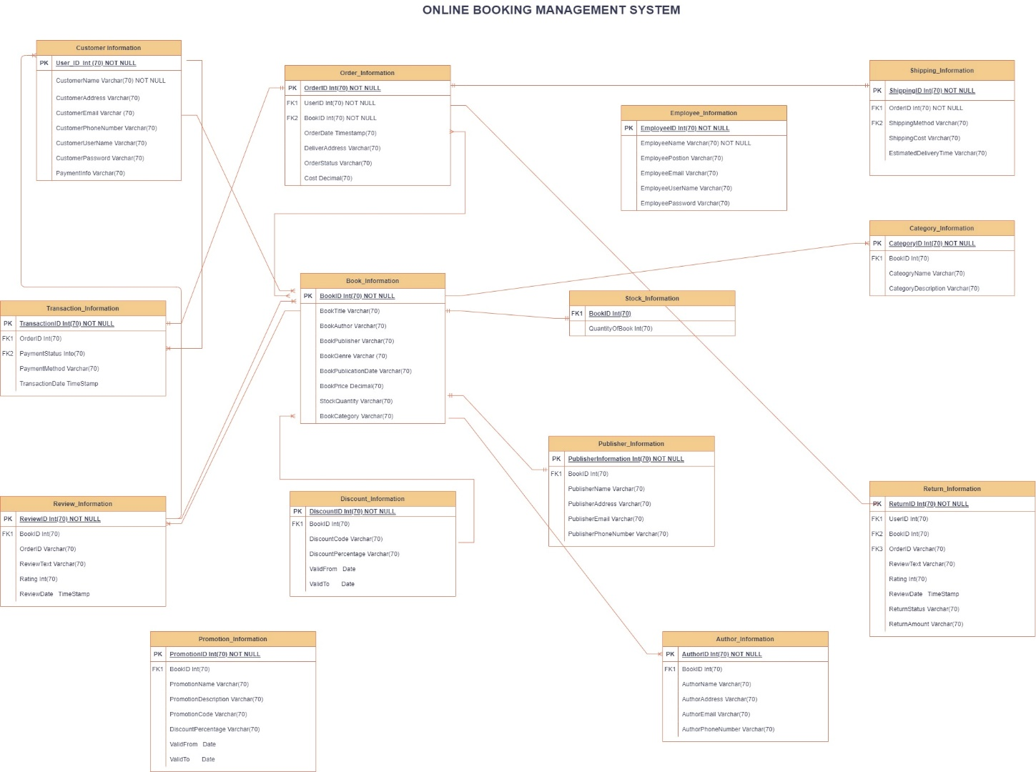

**3.2 RELATIONSHIP BETWEEN TABLES**

**1. Customer Information to Order Information:**

One customer can place multiple orders.

Relationship: Customer.CustomerID (One) -> Order.UserID (Many)

**2. Book Information to Order Information:**

Each order can include multiple books.

Relationship: Book.BookID (Many) -> Order.BookID (Many)

**3.Order Information to Transaction Information:**

Each order can have one transaction.

Relationship: Order.OrderID (One) -> Transaction.OrderID (One)

**4.Customer Information to Transaction Information:**

One customer can have multiple transactions.

Relationship: Customer.CustomerID (One) -> Transaction.UserID (Many)

**5.Book Information to Stock Information:**

Each book can have stock information.

Relationship: Book.BookID (One) -> Stock.BookID (One)

**6. Book Information to Publisher Information:**

Each book is associated with one publisher.

Relationship: Book.BookID (One) -> Publisher.BookID (One)

**7. Book Information to Author Information:**

Each book can have multiple authors.

Relationship: Book.BookID (One) -> Author.BookID (Many)

**8.Book Information to Discount Information:**

Each book can have multiple discounts.

Relationship: Book.BookID (One) -> Discount.BookID (Many)

**9.Book Information to Promotion Information:**

Each book can be associated with multiple promotions.

Relationship: Book.BookID (One) -> Promotion.BookID (Many)

**10.Order Information to Shipping Information:**

Each order is associated with one shipping record.

Relationship: Order.OrderID (One) -> Shipping.OrderID (One)

**11.Book Information to Category Information:**

Each book can belong to multiple categories.

Relationship: Book.BookID (One) -> Category.BookID (Many)

**12. Book Information to Review Information:**

Each book can have multiple reviews.

Relationship: Book.BookID (One) -> Review.BookID (Many)

**13.Order Information to Return Information:**

Each order can have multiple return records.

Relationship: Order.OrderID (One) -> Return.OrderID (Many)

**14.Customer Information to Review Information:**

One customer can write multiple reviews.

Relationship: Customer.CustomerID (One) -> Review.UserID (Many)

**15.Customer Information to Return Information:**

One customer can initiate multiple returns.

Relationship: Customer.CustomerID (One) -> Return.UserID (Many)

**3.3 ACCESS AND CONTENT CONTROLS**

**Customer Information Table:**

**Access Control:** Full access for customers to their own information. Restricted access for employees to view and modify customer data based on their roles.

**Content Control:** Customers can view and update their profile information. Employees with specific roles (e.g., customer service) can access and modify customer data for support purposes.

**Book Information Table:**

**Access Control:** Full access for employees to manage book information. Limited access for customers to view book details.

**Content Control:** Customers can view book details, while employees can add, update, and delete book information.

**Order and Transaction Information Table:**

**Access Control:** Full access for employees to manage orders and transactions. Limited access for customers to view their own order and transaction history.

**Content Control:** Customers can view their order history, while employees can manage and update order and transaction details.

**Employee Information Table:**

**Access Control:** Full access for administrative users. Limited access for other employees based on their roles.

**Content Control:** Employees can update their own profiles. Administrative users can manage employee information.

**Stock, Publisher, Author, Discount, Promotion, Shipping, Category, Review, Return Information Tables:**

**Access Control:** Full access for employees to manage related data. Limited access for customers to view relevant information.

**Content Control:** Customers can view relevant information, while employees can manage and update related data.

**ALLOWABLE VALUES:**

**BookGenre:**

Allowable values for the "BookGenre" field may include options like Fiction, Non-Fiction, Mystery, Romance, Science Fiction, etc.

**OrderStatus:**

Allowable values for the "OrderStatus" field may include options like Processing, Shipped, Delivered, Cancelled, etc.

**PaymentStatus:**

Allowable values for the "PaymentStatus" field may include options like Pending, Paid, Failed, Refunded, etc.

**USERS AND ROLES:**

**Customer Roles:**

Customers have basic roles with read access to their own information and the ability to place orders.

**Employee Roles:**

Different employee roles, such as Customer Service Representative, Inventory Manager, and Sales Manager, with varying levels of access to manage specific aspects of the system.

**Administrative Users:**

Superuser or administrator roles with full access to all functionalities and data.

**User Authentication:**

Use secure authentication methods (e.g., username/password, multi-factor authentication) for both customers and employees.

**4. LOGICAL DATABASE DESIGN PHASE**

**4.1 OBJECTIVE:**

Provide a user-friendly platform for customers to browse, search, and purchase books online. Efficiently manage inventory, orders, and customer information. Enhance the overall user experience through a well-designed and intuitive website.

**4.2 DESIGN GOALS:**

* **User-Friendly Interface:** Create an interface that is easy to navigate, ensuring a positive experience for customers.
* **Efficient Order Processing:** Streamline the order processing system to minimize delays and errors.
* **Comprehensive Search and Browse Features:** Implement robust search and browse functionalities to help customers find books easily.
* **Secure Transactions:** Ensure secure handling of customer payment information to build trust and meet security standards.
* **Inventory Management:** Implement a system to efficiently track and manage book inventory levels to prevent overselling.

**4.3 FUNCTIONALITIES:**

* **User Registration and Authentication:** Allow customers to create accounts, log in, and manage their profiles.
* **Book Catalog:** Display a comprehensive catalog of books with details like title, author, genre, price, and availability.
* **Search and Filters:** Provide search functionality and filters to help customers find specific books based on criteria like genre, author, and price range.
* **Shopping Cart:** Enable customers to add and remove items from their shopping carts before proceeding to checkout.
* **Checkout Process:** Facilitate a smooth and secure checkout process, including address entry and payment options.
* **Order History:** Allow customers to view their order history and track the status of current orders.
* **Inventory Management:** Provide administrators with tools to manage book inventory, update stock levels, and add new products.
* **Discounts and Promotions:** Implement discount codes and promotional offers to incentivize purchases.
* **User Reviews and Ratings:** Allow customers to leave reviews and ratings for books to assist others in making informed decisions.
* **Returns and Refunds:** Implement a process for handling returns, tracking return status, and issuing refunds if necessary.

**4.4 BUSINESS RULES:**

* **Payment Processing Rules:**
* Payments should be processed securely using industry-standard encryption.
* Payment confirmation must be received before an order is marked as successful.
* **Inventory Management Rules:**
* The system should automatically update the stock quantity after each successful purchase.
* Notifications should be triggered when the stock of a particular book falls below a predefined threshold.
* **User Account Rules:**
* Customers must provide valid and verifiable information during the registration process.
* Passwords must meet security standards, and account recovery mechanisms should be in place.
* **Order Fulfillment Rules:**
* Orders should be processed in a timely manner, and customers should be notified of any delays.
* Shipping information provided by customers must be accurate to ensure successful delivery.
* **Discount and Promotion Rules:**
* Discounts and promotions must have valid start and end dates.
* Customers should only be able to use one discount or promotion per order.
* **Return and Refund Rules:**
* Returns should be accepted within a specified timeframe.
* Refunds should be issued promptly upon the approval of a return.

**4.5 DDL For Online BookStore Management**

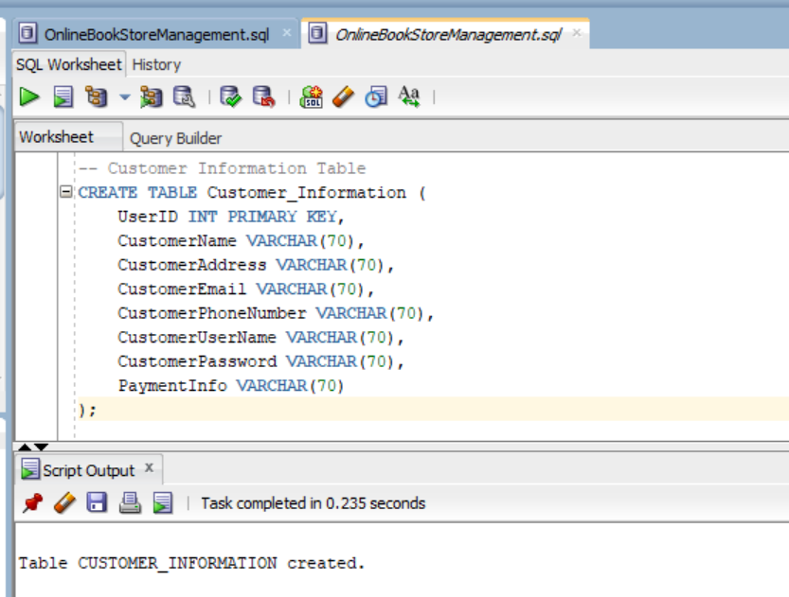

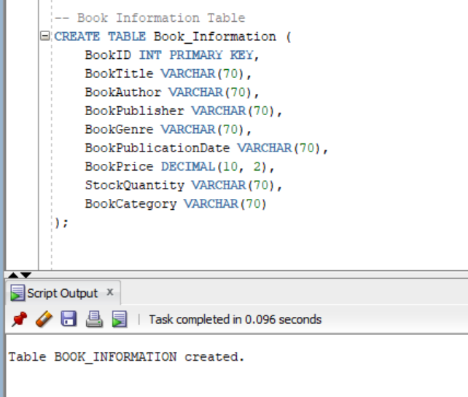

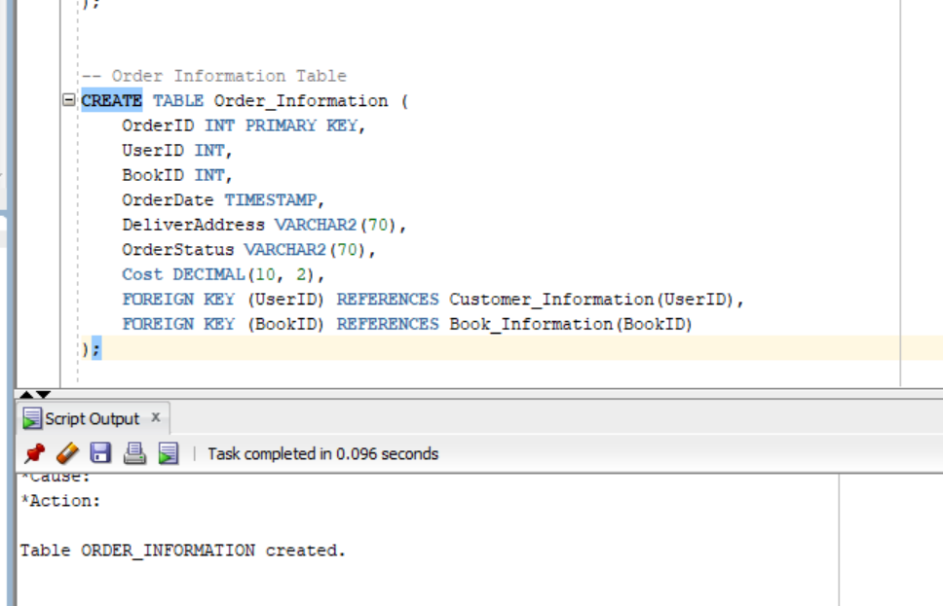

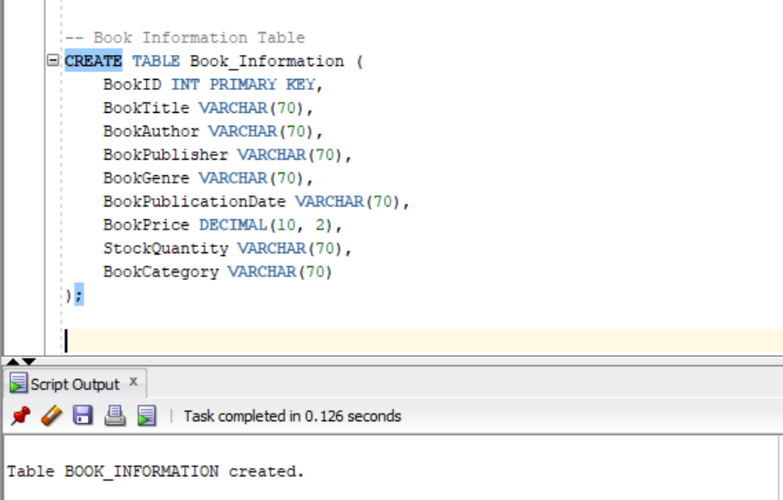

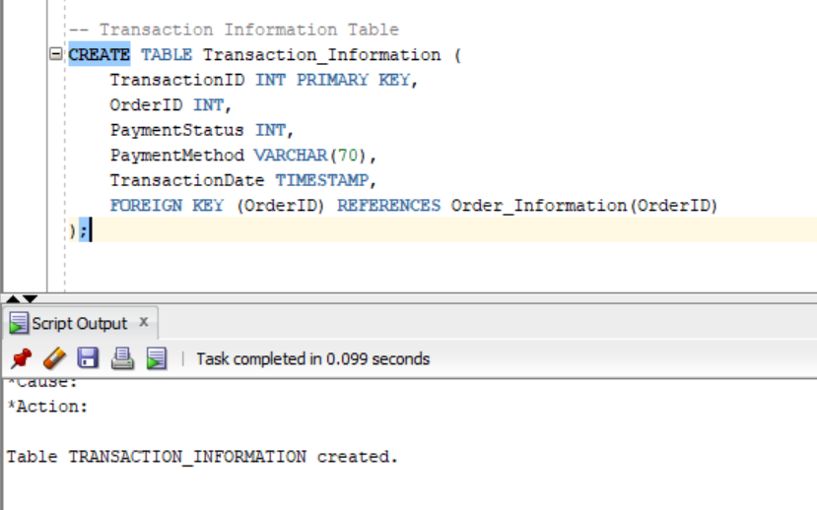

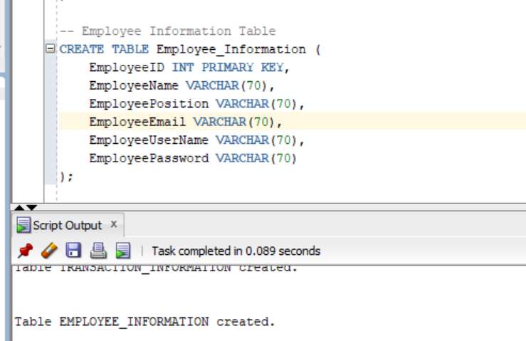

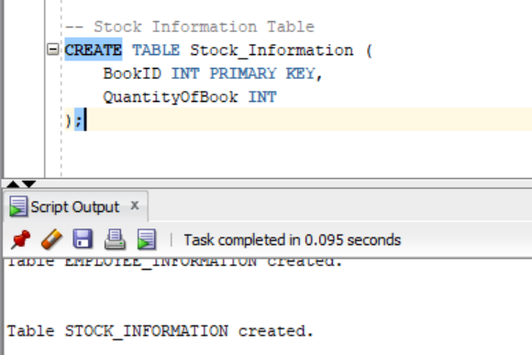

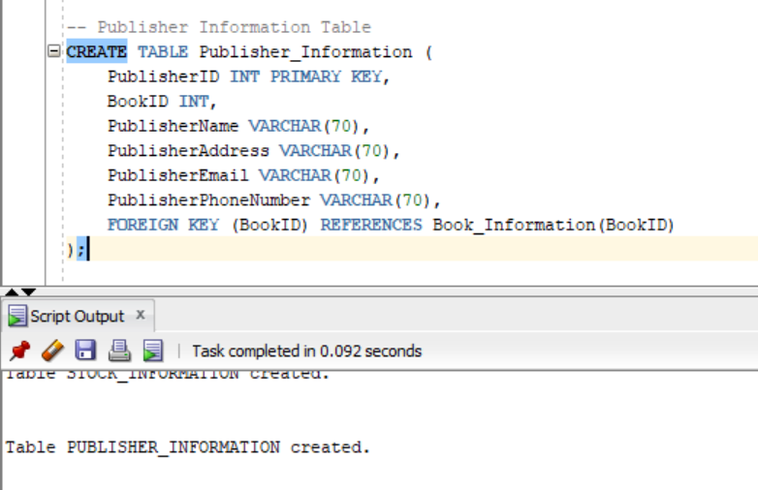

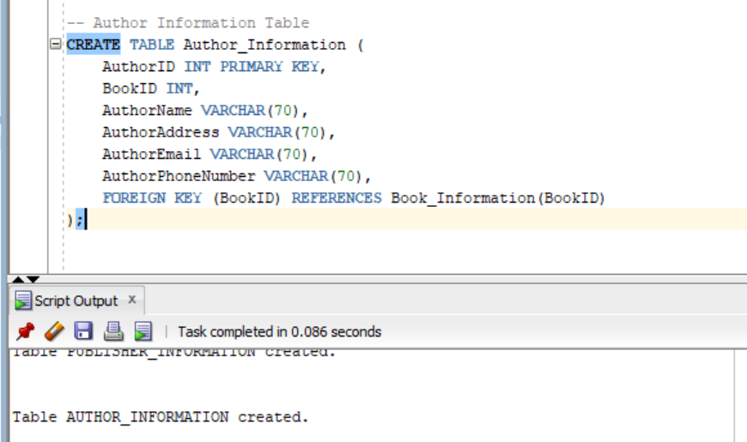

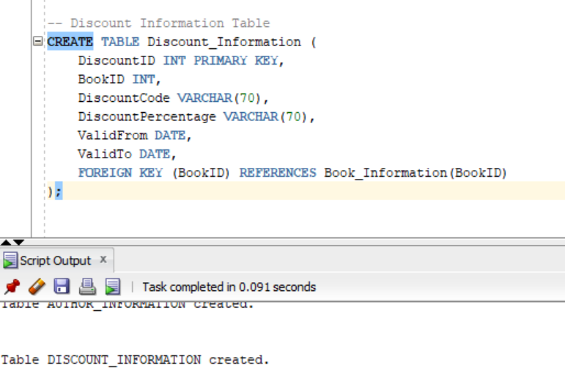

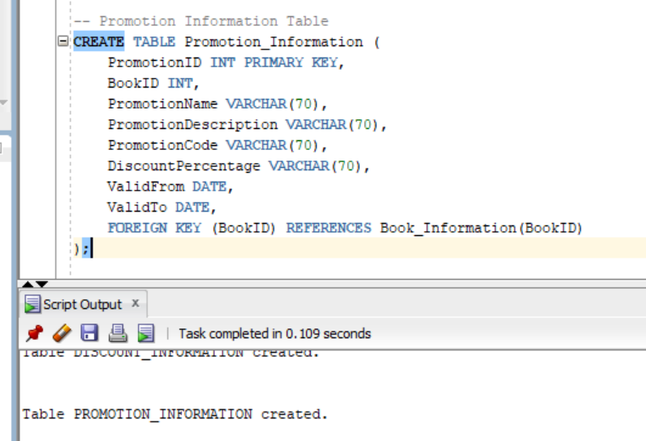

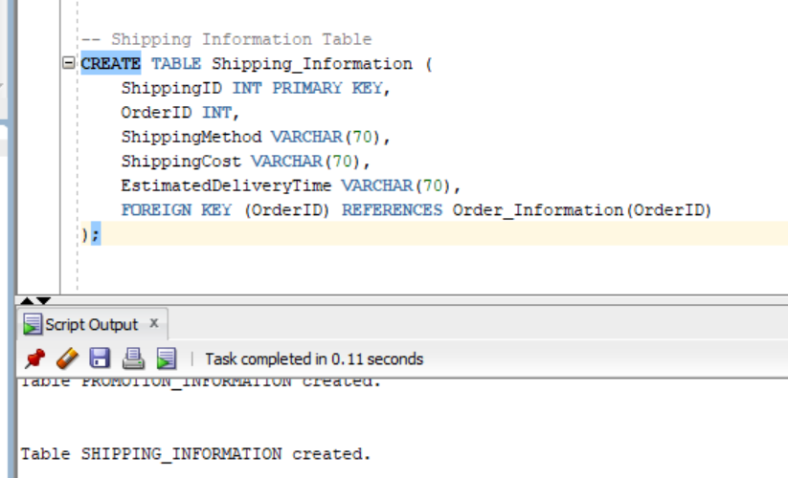

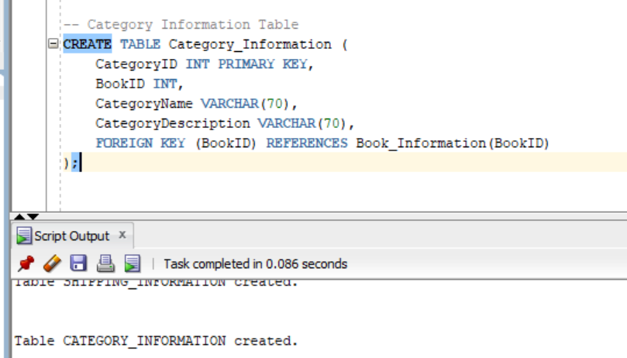

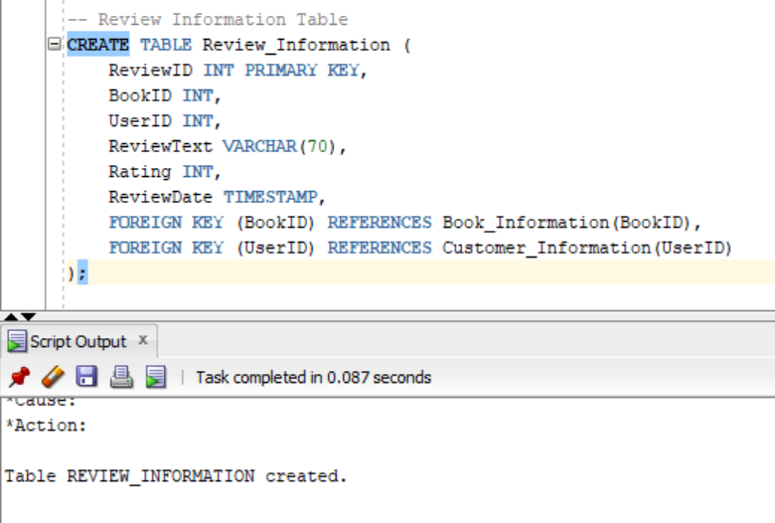

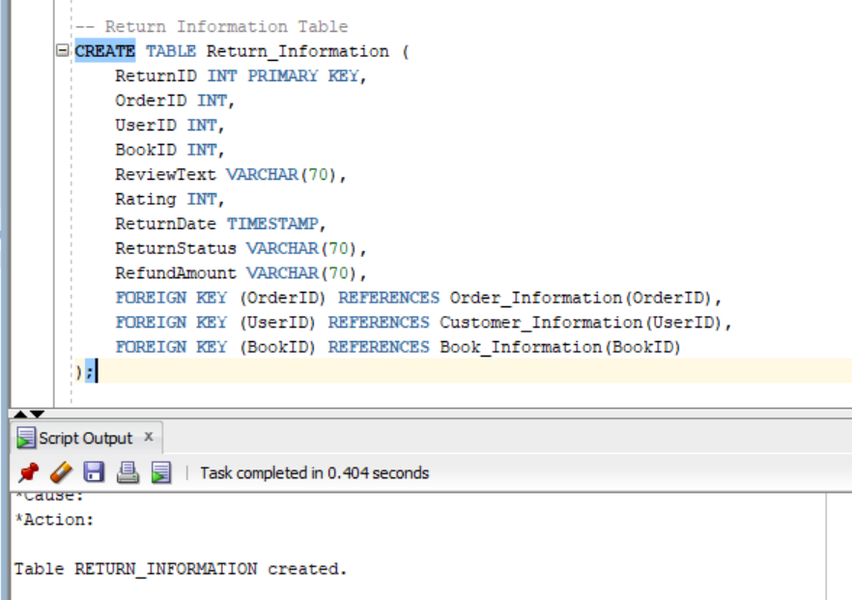

**4.6 DML for Online Bookstore Management**

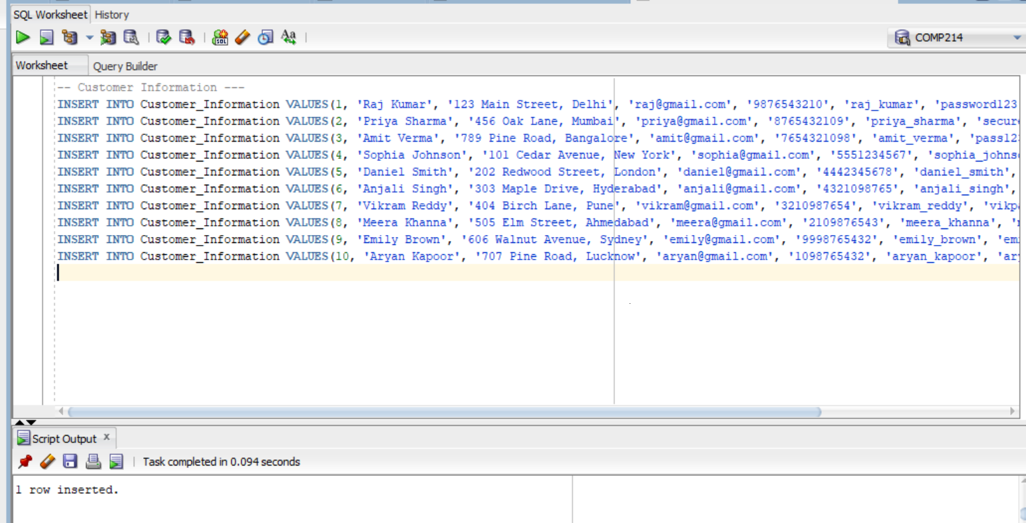

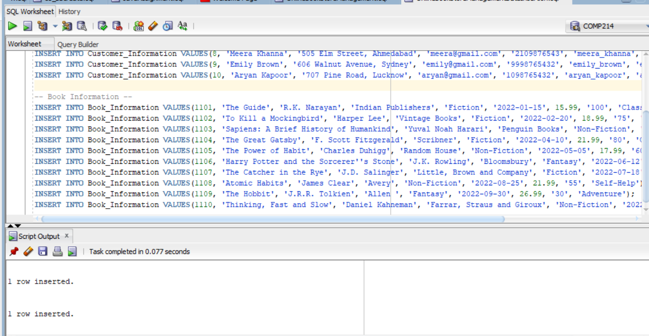

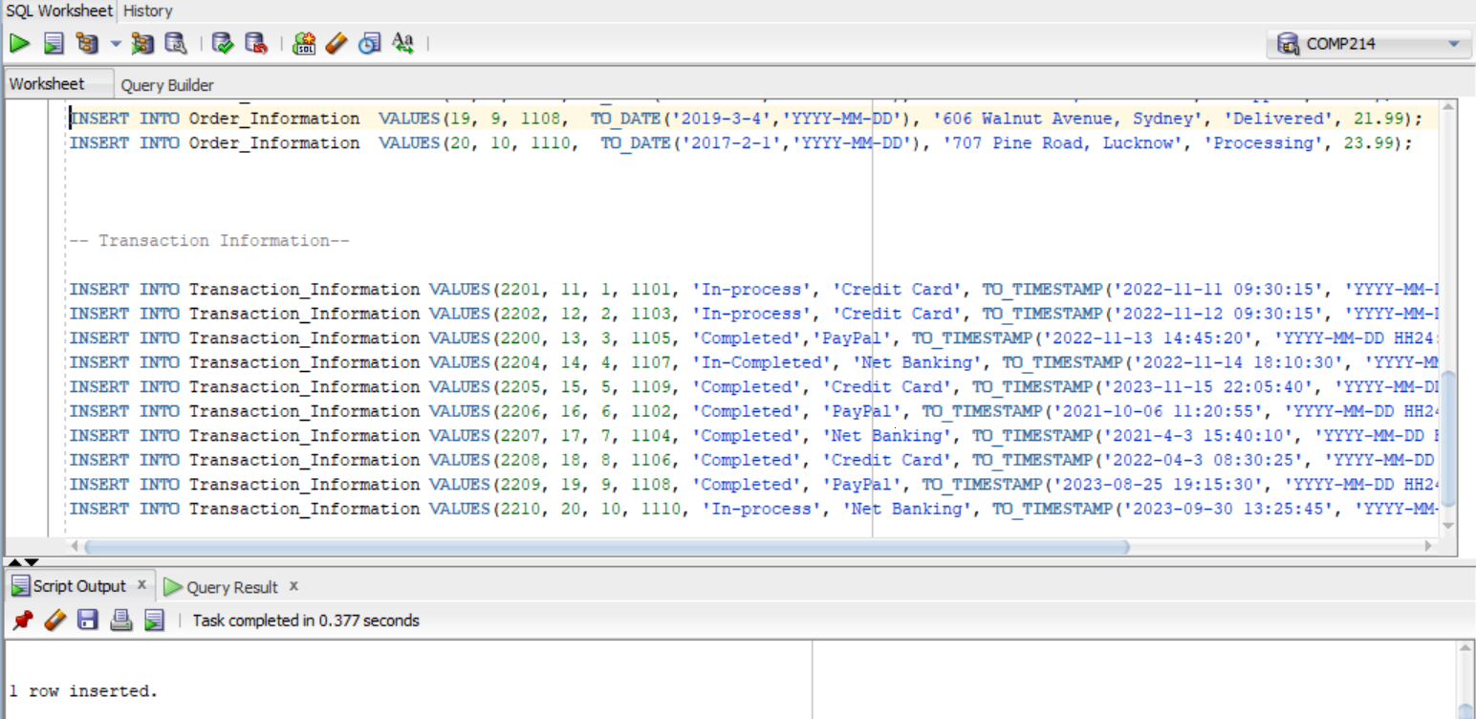

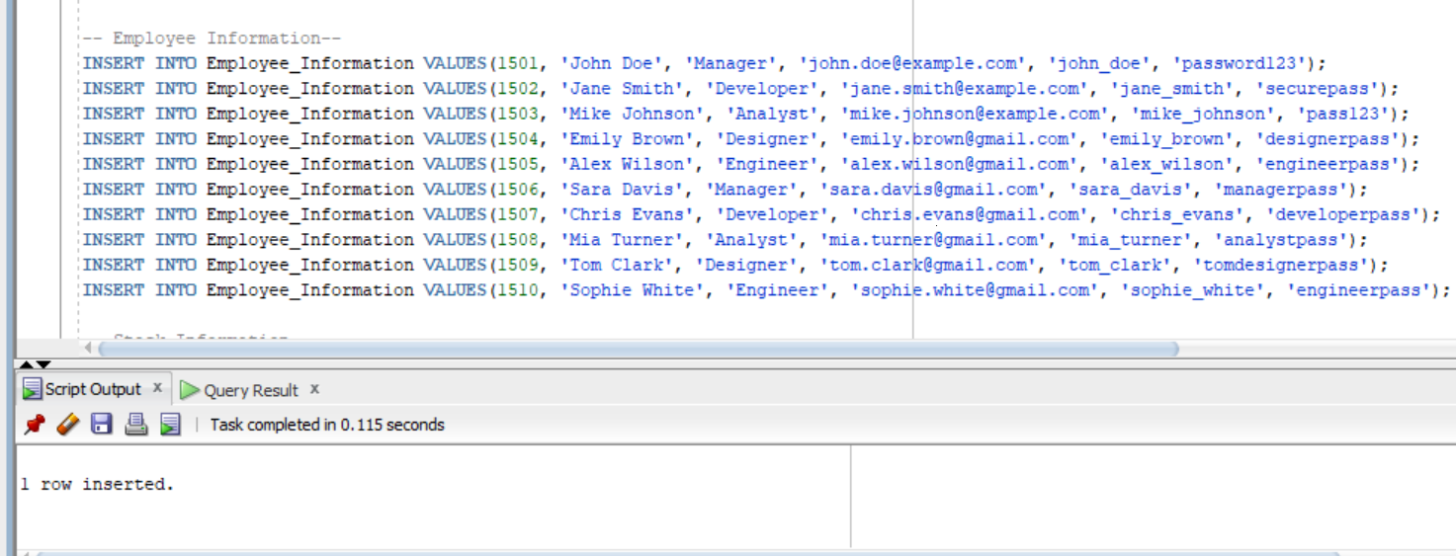

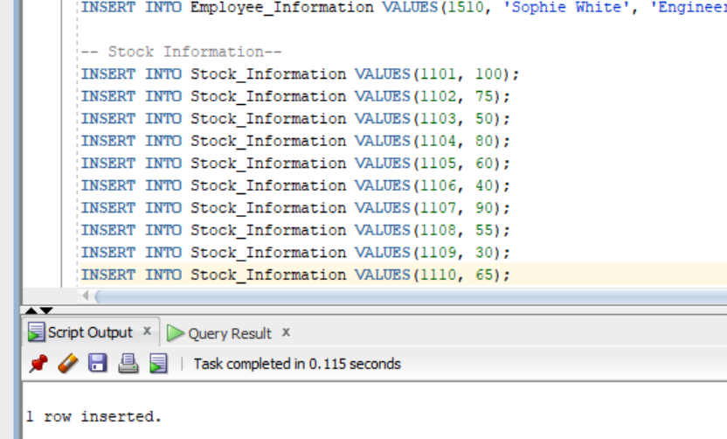

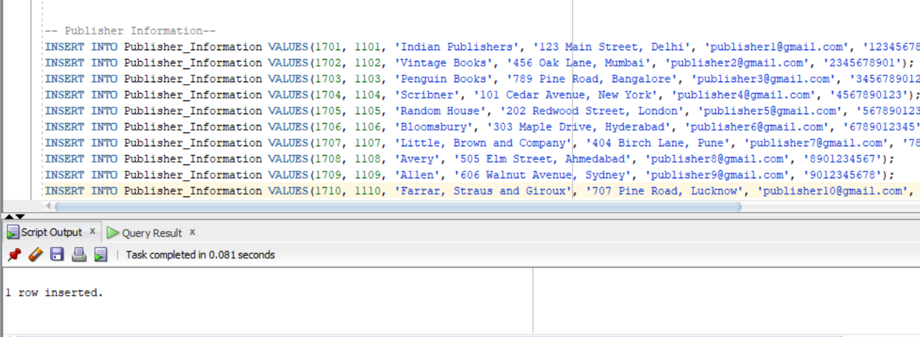

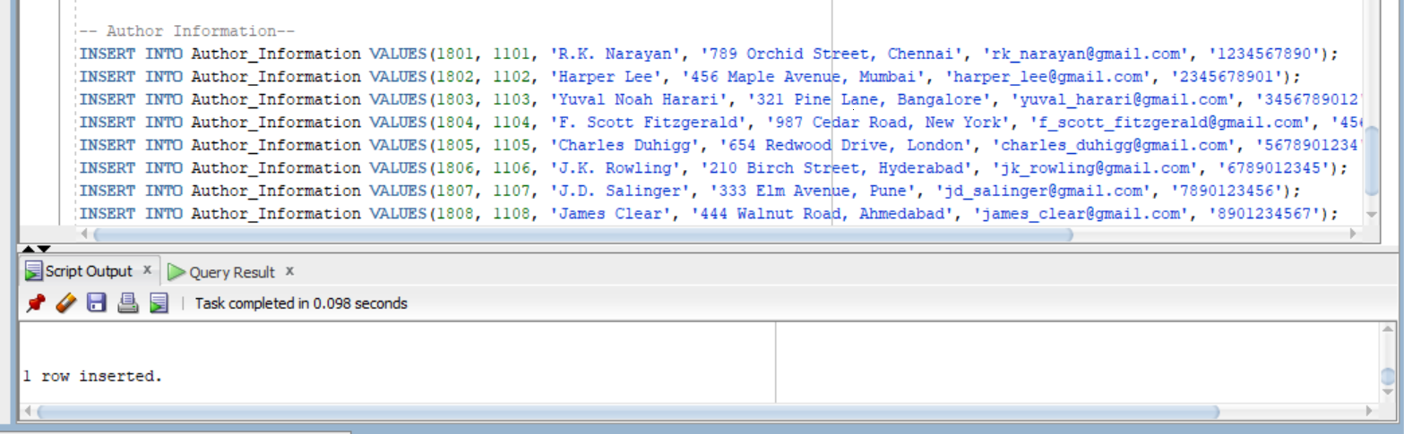

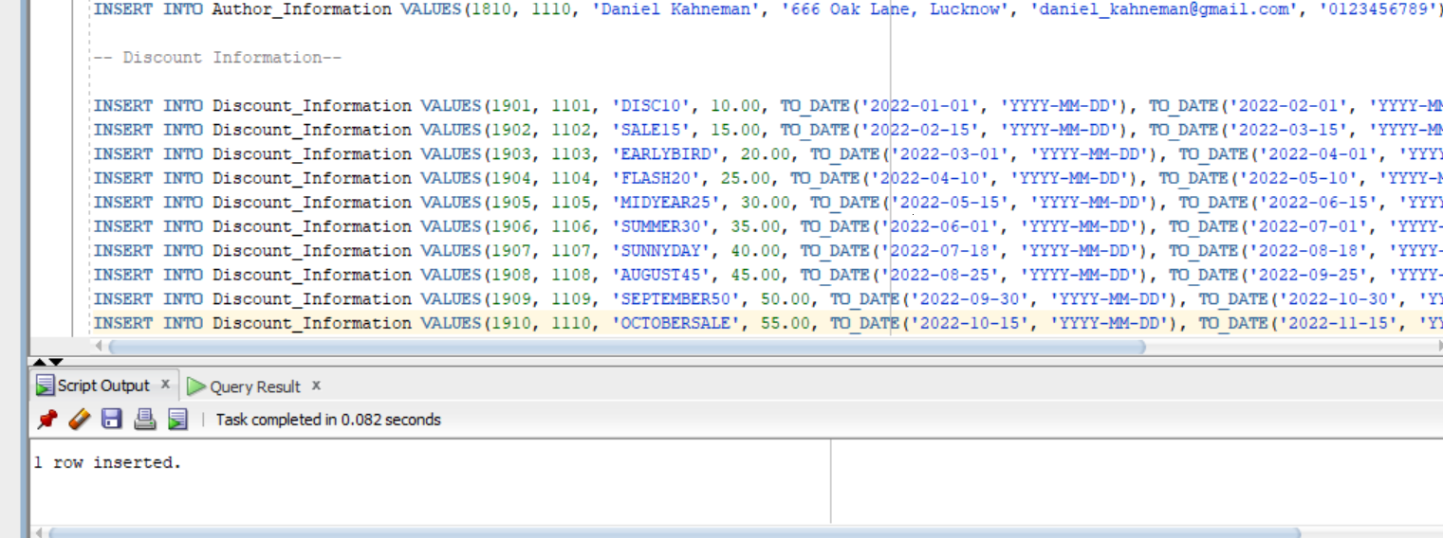

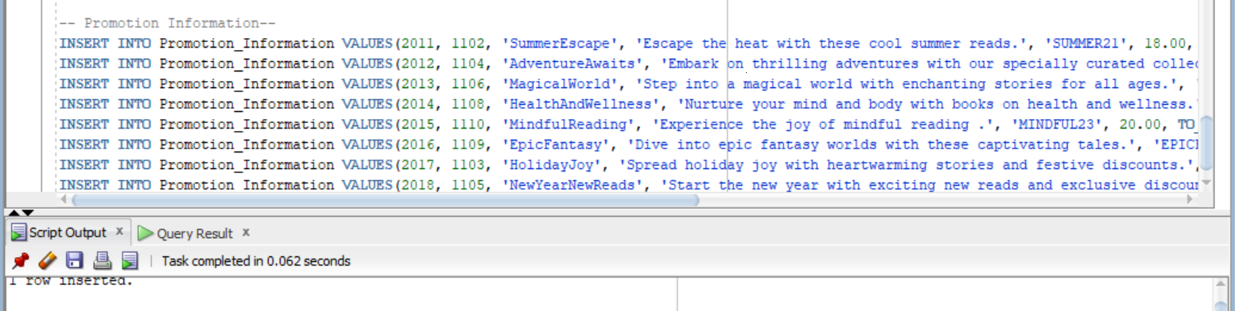

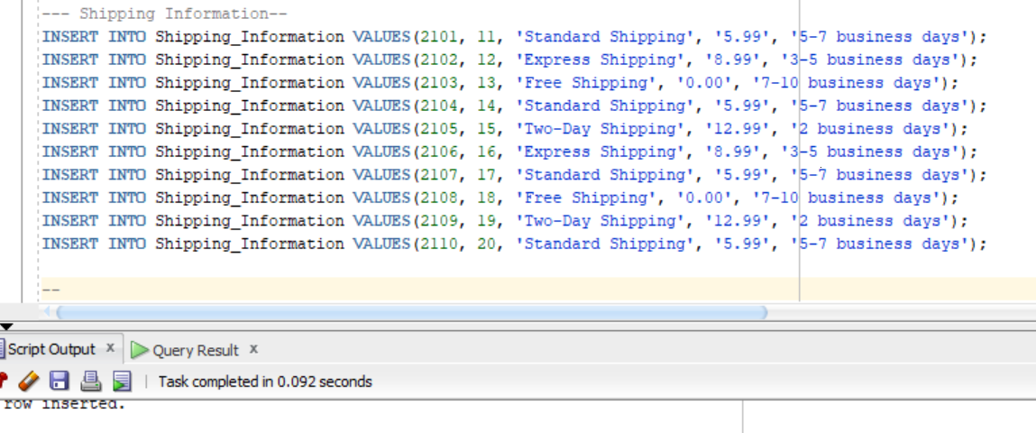

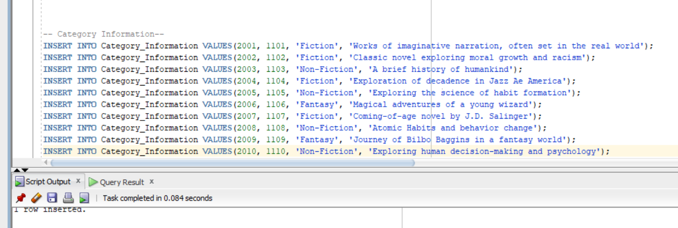

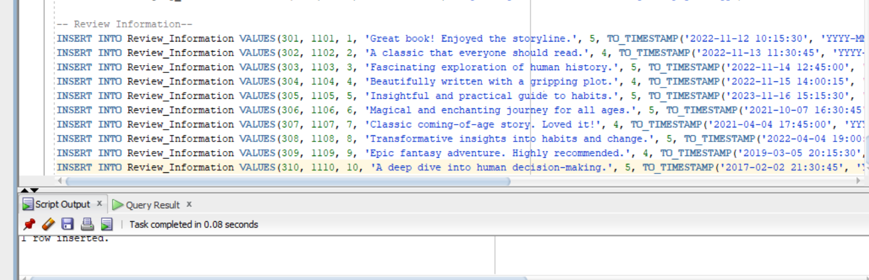

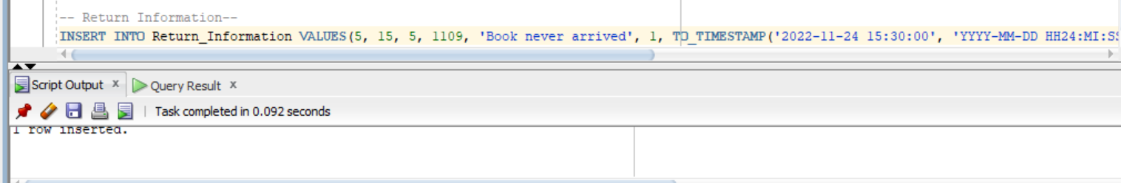

**5. PHYSICAL DATABASE DESIGN PHASE**

**5.1 Sequence**

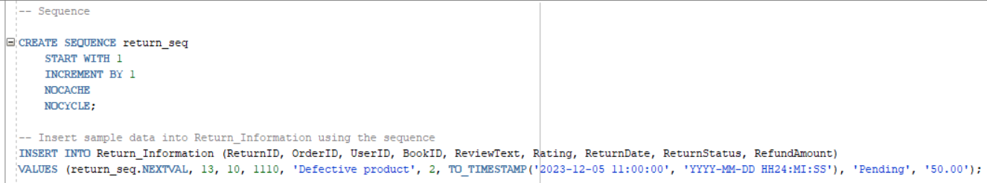

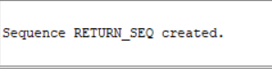 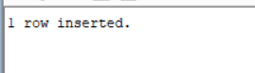



**5.2 View**

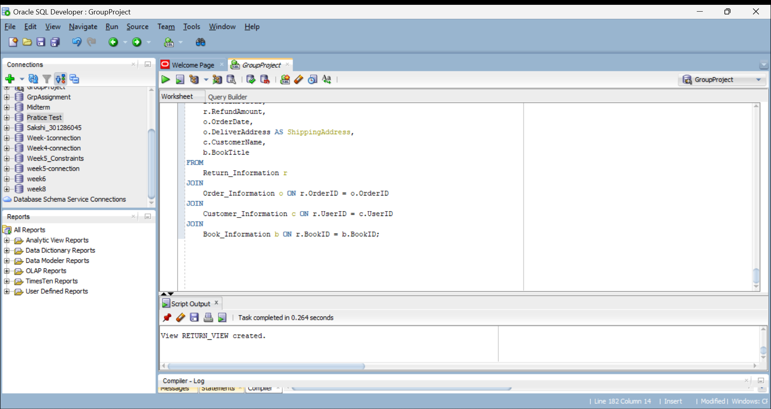

**5.3 Cursor**

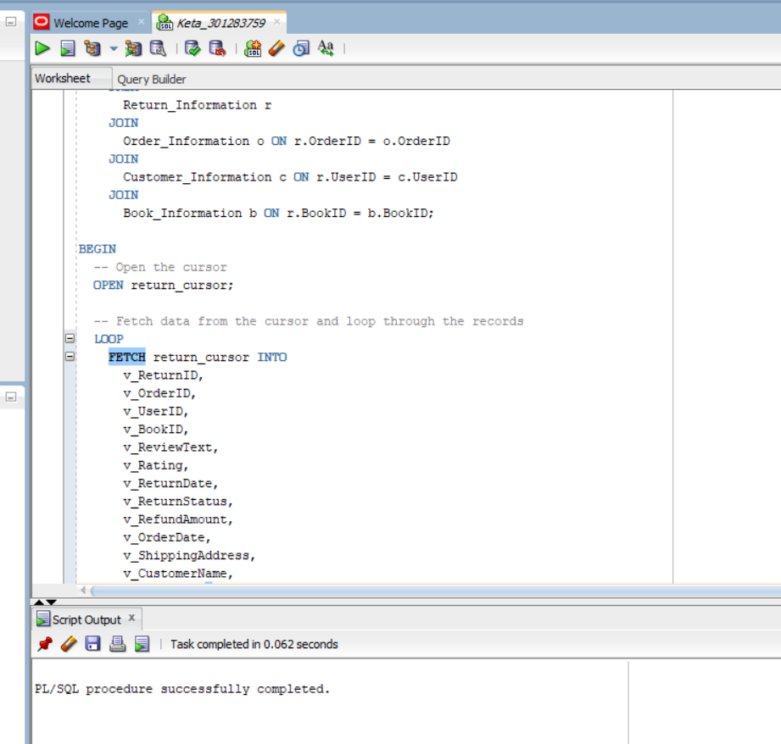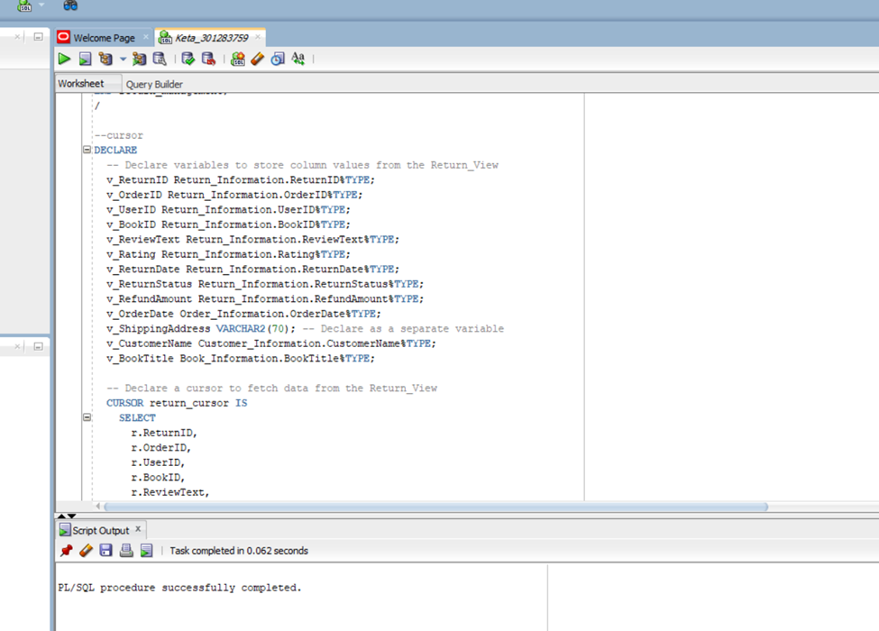

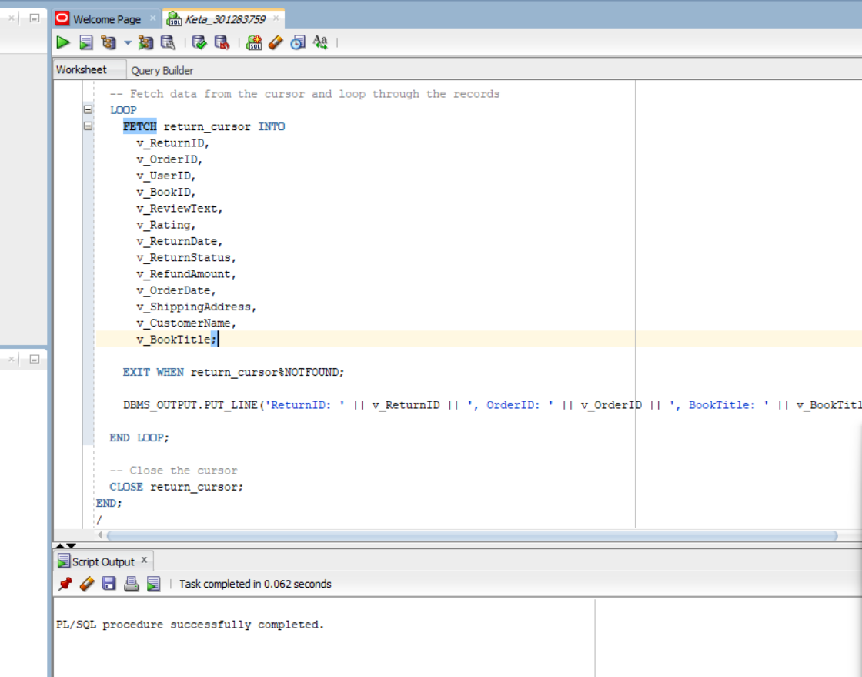

**5.4 Function no-1**

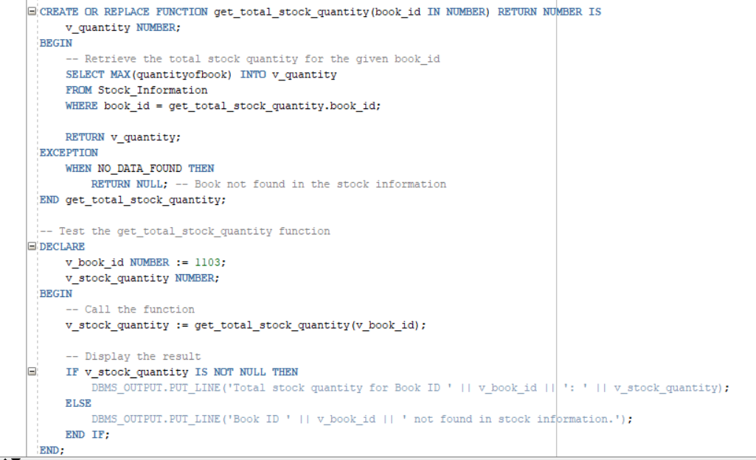

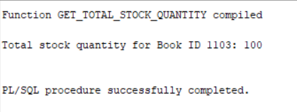

**Function no- 2**

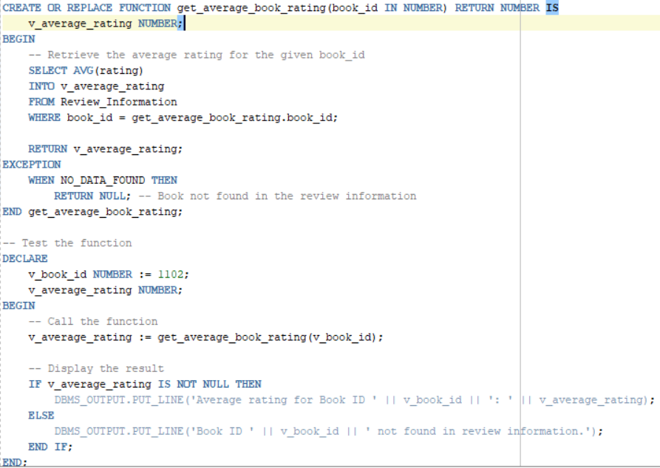

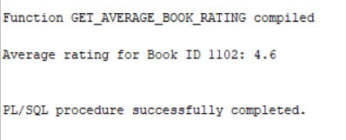

**5.5 Procedure**

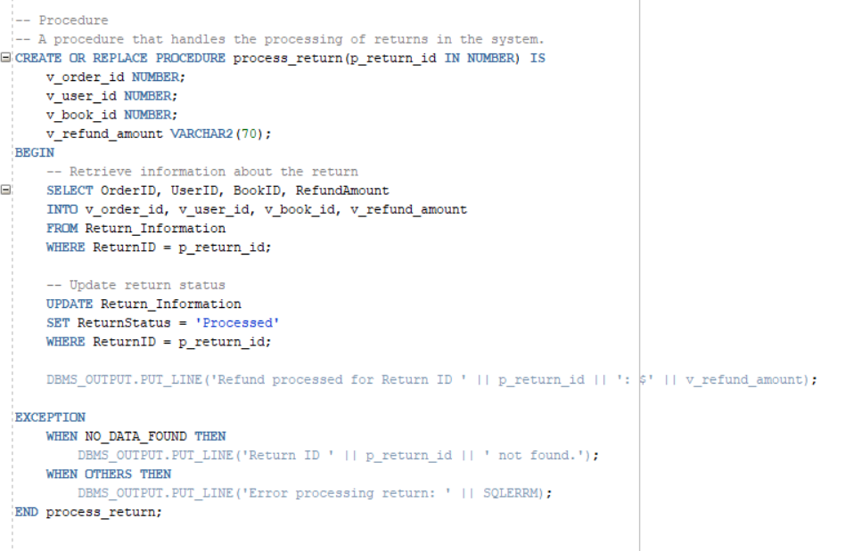

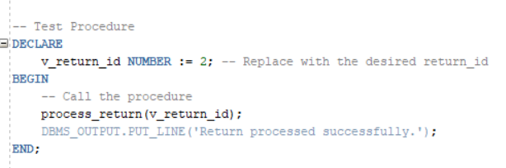

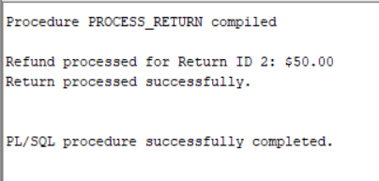



**5.6 Trigger**

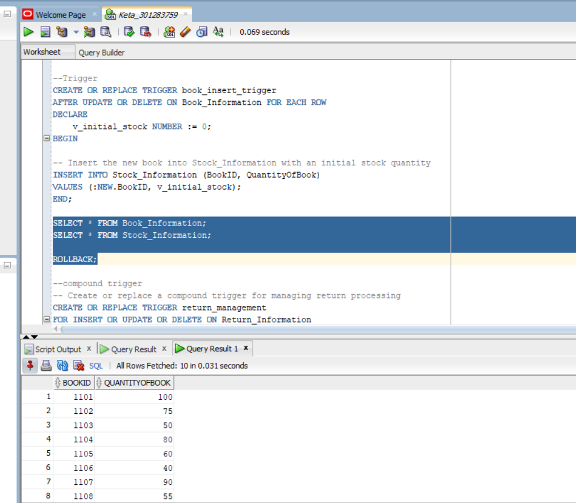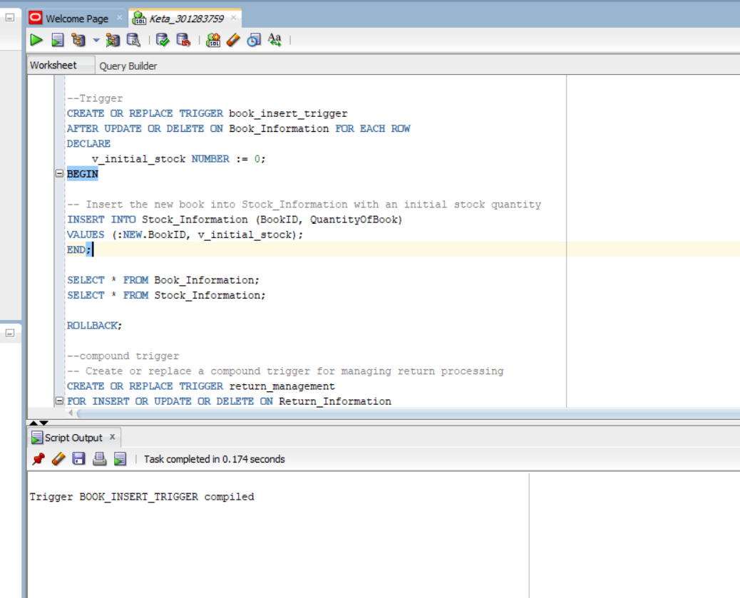

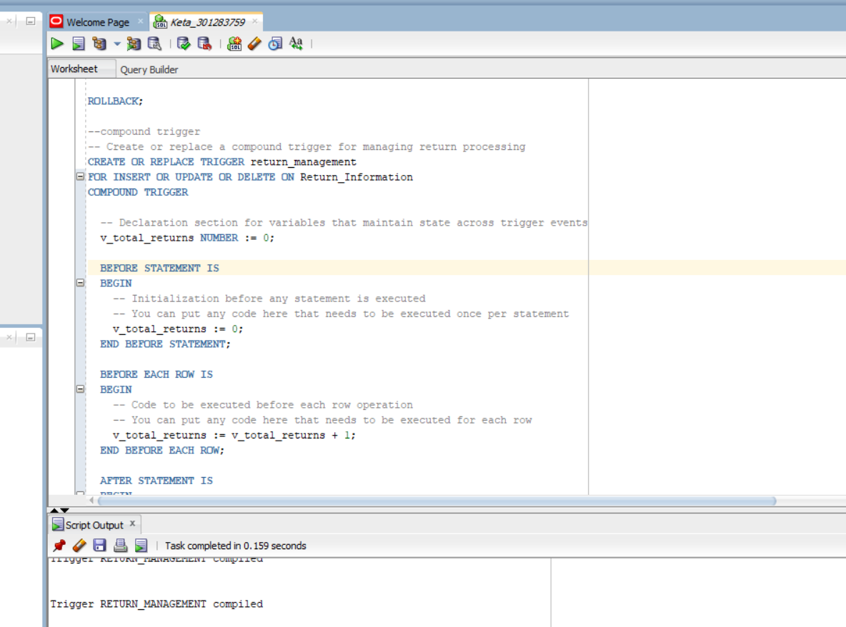

**5.7 Packages**

